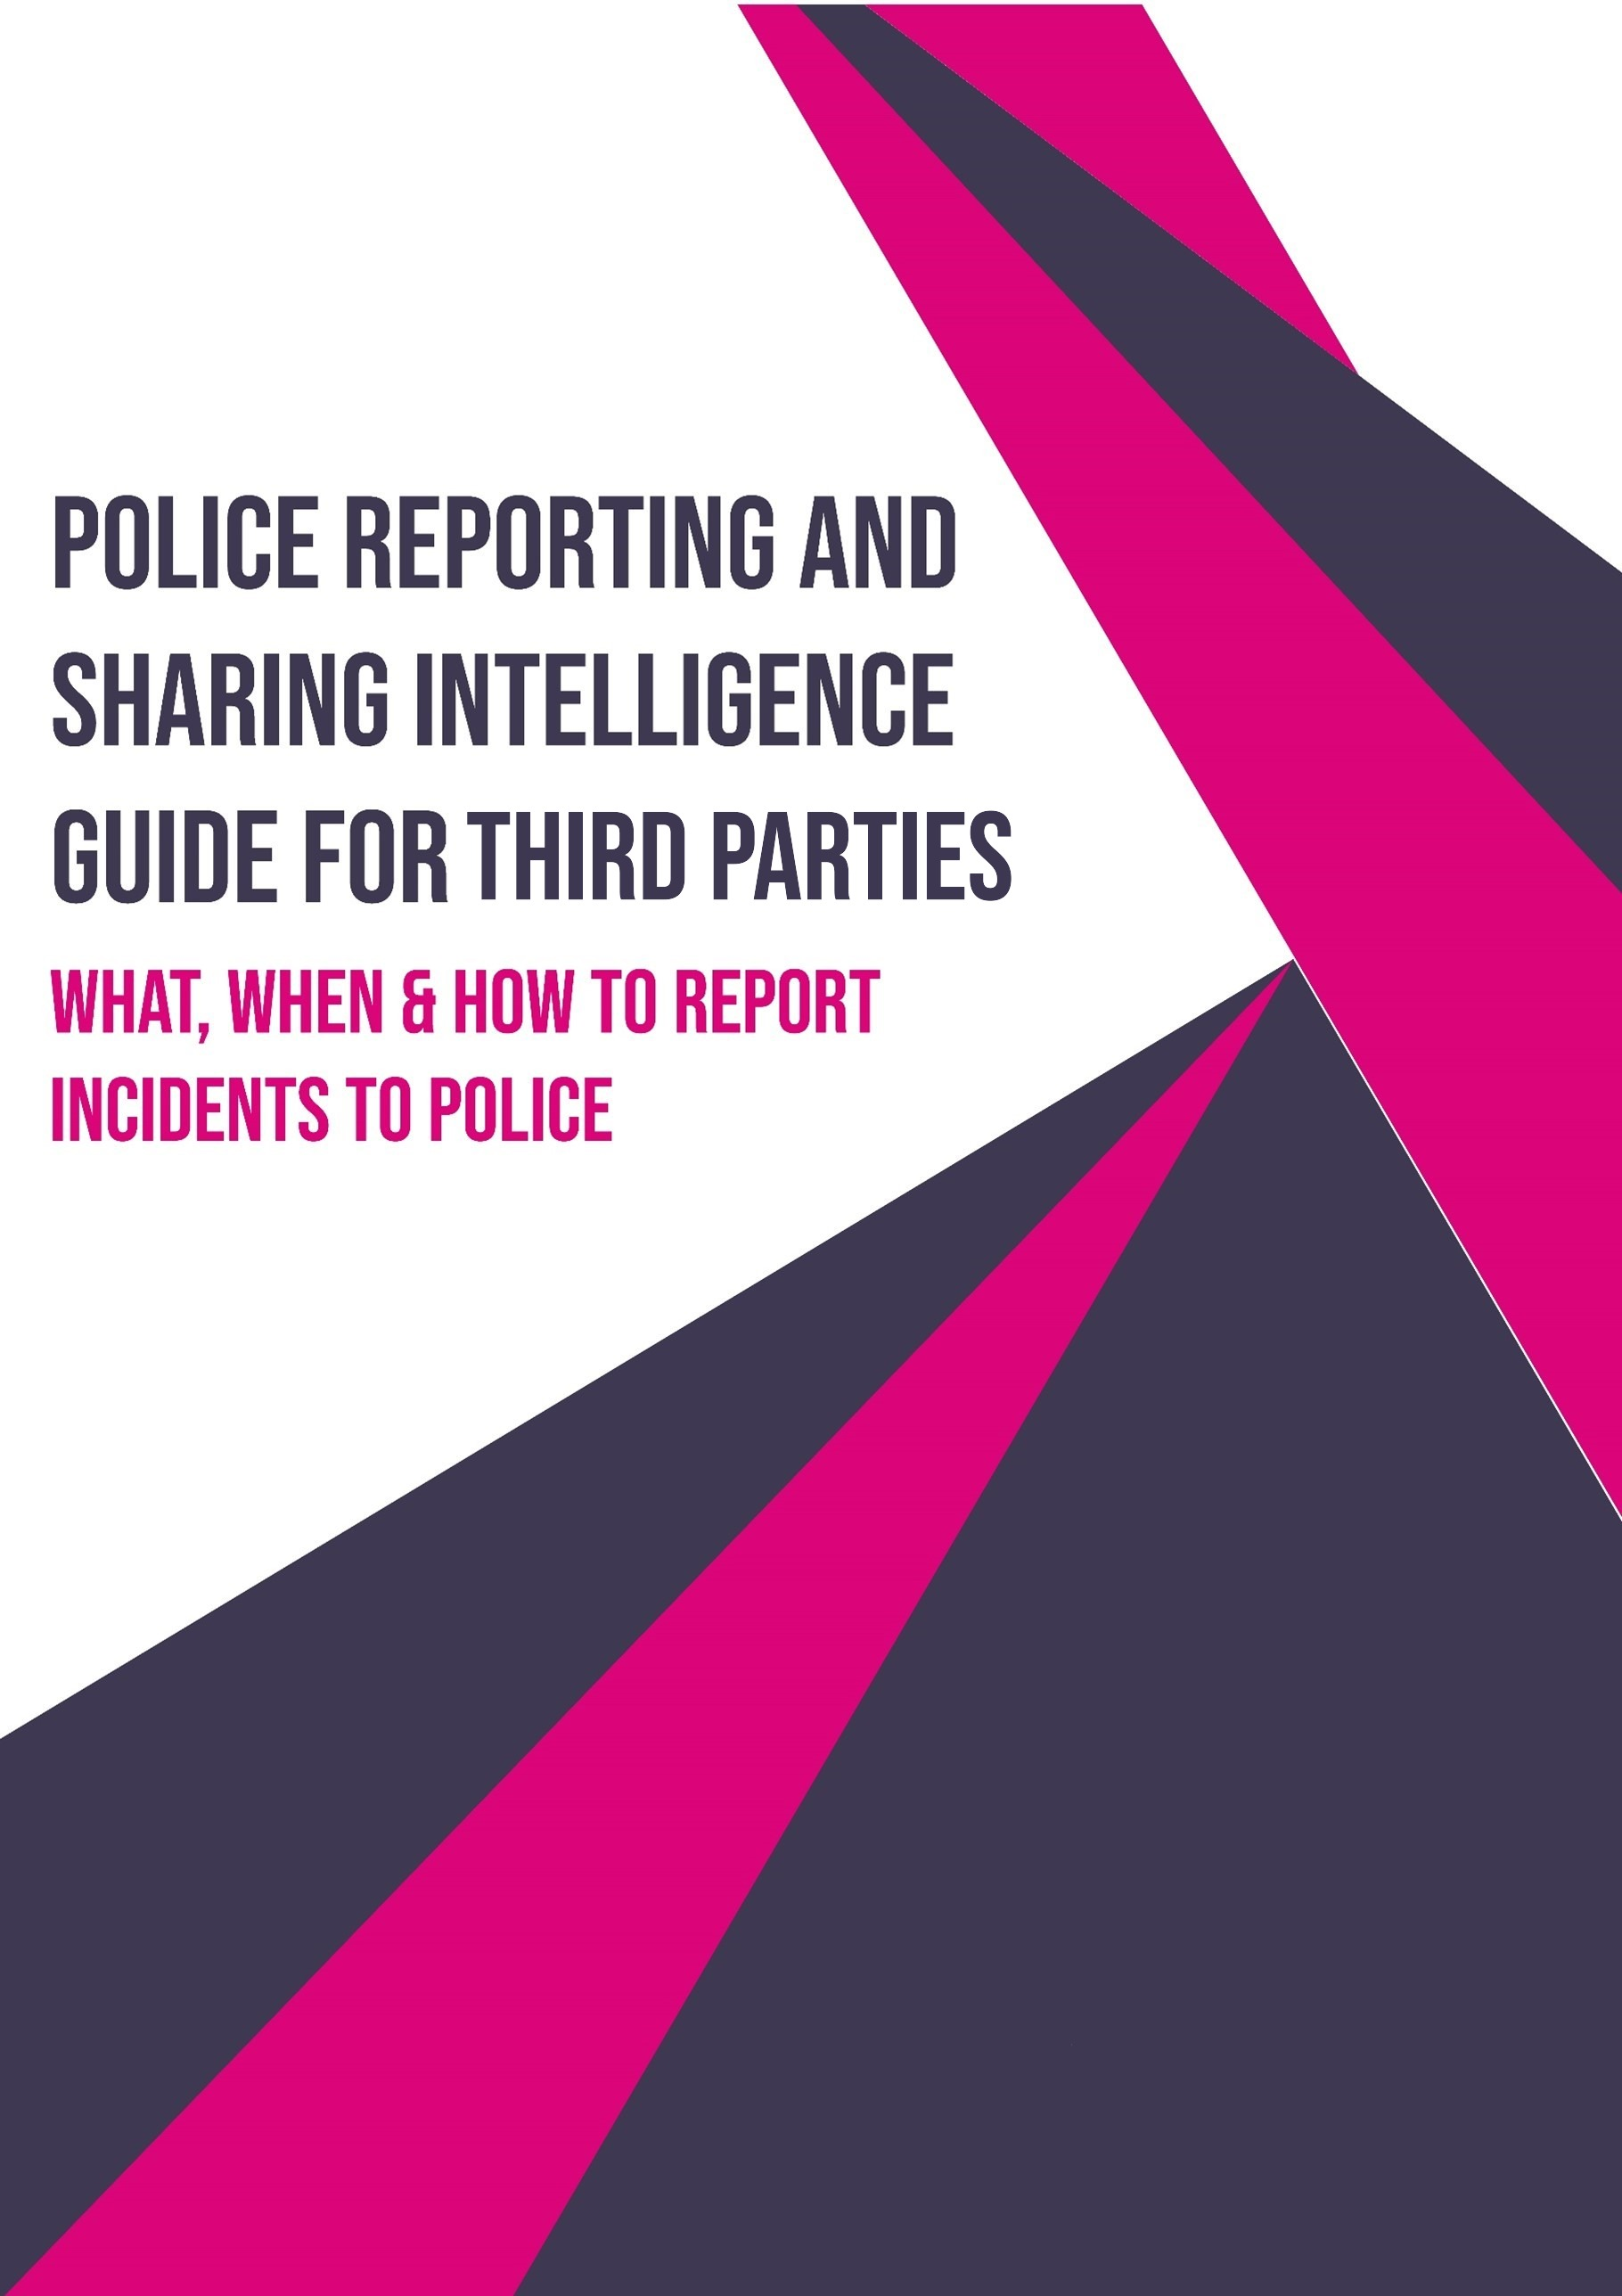

# Purpose of the Guide

This guide is designed to support partners and third-party organisations in understanding when and how to appropriately contact Norfolk and Suffolk Constabulary. It aims to:

* **Promote consistency** in how external contacts are managed across both forces.
* **Strengthen relationships** between the Constabulary and its partners by encouraging timely, relevant, and effective communication.
* **Support safeguarding and public safety** by ensuring that concerns are directed to the right teams using the correct channels.
* **Reduce delays and miscommunication** by providing clear guidance on contact points and escalation pathways.

While not exhaustive, this guide serves as a practical reference to improve operational efficiency and mutual understanding

The information contained within this guide may be subject to change over time. While every effort will be made to update this document promptly to reflect any changes, partners and third-party organisations are advised to seek confirmation from their local Policing Teams, consult official online resources, or contact 101 if there is any uncertainty.

The reporting of offences, intelligence, or safeguarding concerns to the police does not prevent partners and third-party organisations from taking action in accordance with their own professional duties and procedures. Engagement with the Constabulary should complement, not replace, the responsibilities held by individual agencies or professionals.

# Partners and 3rd Party Reporting

Contact Norfolk/Suffolk Police on 999

# Sharing Intelligence with Police

## What is intelligence?

Intelligence refers to information that may assist law enforcement in preventing, detecting, or disrupting crime, safeguarding individuals, or understanding emerging threats. It is not necessarily evidence or a confirmed fact, but rather information that may be relevant to policing activity.

Intelligence should be shared even if it seems minor or unverified—it may contribute to a broader picture when combined with other sources.

*Examples:*

* *‘X’ is believed to be carrying a knife. No knife has been seen by the reporting person.*
* *It has been reported by ‘X’ that drugs are being dealt at location ‘Y’.*
* *The following individuals are suspected of being in a fight last week.*
* *’X’ drives under the influence of drink / drugs*

## What is not intelligence?

While partners and third parties are encouraged to share relevant information with the police, it’s important to distinguish between intelligence and other types of reporting. The following are **not considered intelligence** and should be directed through appropriate channels:

* **Criminal offences** that require recording as a crime, such as assaults, theft, criminal damage.
* **Safeguarding concerns**, including Mental health issues, Vulnerable individuals, Children at risk
* **Incidents requiring immediate action** or posing an immediate threat to life, limb or property.

These types of reports should be made via 999 (in emergencies), 101 (non-emergencies), or through online crime reporting.

## How do you submit intelligence to the Police?

Partners and third-party organisations should submit intelligence using the **Intelligence Submission Form (Appendix A)**.

When completing the form:

* Include as much detail as possible—specific names, dates, locations, and descriptions help assess the value of the intelligence.
* If the information is not known to you personally, please make this clear.
* It is important to state where the information came from and whether anyone else is aware of it. This helps the Constabulary assess the reliability of the intelligence and take appropriate steps to safeguard the source.

All submitted intelligence is stored confidentially within the Intelligence Unit, ensuring that sources are protected and not exposed or placed at risk.

# Appendix A – Intelligence Submission Form

Intelligence Submission

The below form is to be used when submitting intelligence to Norfolk or Suffolk Constabulary.

If your intelligence contains any immediate threat, harm or risk please call 999 or 101 as the email accounts are not monitored 24/7.

Please email your completed form to the relevant Force:

**Norfolk:** [CIB@Norfolk.police.uk](mailto:CIB@Norfolk.police.uk)

**Suffolk:** [CIB@Suffolk.police.uk](mailto:CIB@Suffolk.police.uk)

|  |  |  |  |  |  |
| --- | --- | --- | --- | --- | --- |
| **Intelligence Report** | | | | | |
| Name of person completing this form |  | | Date/Time of Event | |  |
| Who provided this information *(Full Name address and DOB)* |  | | | | |
| **Provenance** | | | | | |
| How does the person completing this form know this information? | | | |  | |
| Who else knows the information? | | | |  | |
| When did the person providing the information first know it to be the case? | | | |  | |
| When did the person providing the information last know it to be the case? | | | |  | |
| Will the person providing the information be able to provide more information regarding this subject in the future? | | | |  | |
| Report Title | |  | | | |
| Submission Text –   * *Please include 3 identifying pieces of information for people documented or NFD (No Further Details) where details unknown.* I.E name, DOB, address. * Ensure each point is succinct I.E *John Smith – DOB: 01/01/90 is dealing drugs from Lowestoft Town Centre.* | | | | | |
|  | | | | | |
| What action have you taken to in relation to this:  *I.E who else have you made aware of this* | |  | | | |

|  |  |
| --- | --- |
| Date and time |  |