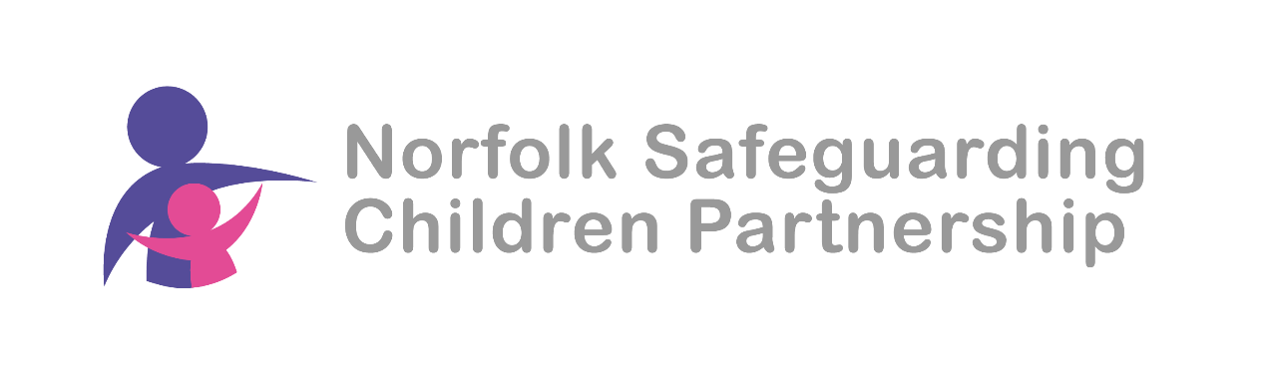

Safeguarding Intelligence & Performance Co-Ordinator
Job Share – Leading on Audit, Policy & Research

JOB ADVERT

The Norfolk Safeguarding Children Partnership (NSCP) is responsible for co-ordinating and monitoring the effectiveness of local safeguarding arrangements on behalf of the statutory partners: the Local Authority, Police and the NHS integrated Care Board. Supporting this, is a small, highly effective Business Unit. We work to strengthen the multi-agency response to safeguarding children by analysing practice through multi-agency audits and monitoring the response to recommendations from audits, Safeguarding Practice Reviews (SPRs), independent scrutiny and Section 11 safeguarding self assessment.

The successful applicant will be experienced in conducting multi-agency audits, with strong analytical and writing skills and a background in safeguarding and partnership working,

In addition, the post holder will be responsible for reading, analysing and summarising all national policy developments and relevant published research to ensure that the NSCP’s forward plan is cognisant of changes to the safeguarding landscape and responding accordingly.

The role will be overseen by the Head of NSCP Business Delivery. The post is 0.4 FTE, with other analytical and monitoring duties shared with the other Safeguarding Performance & Intelligence Officer (SIPCo).

Closing Date: 10 February 2025
Interview Date: 24 February

Apply here.

If you would like an informal discussion with the Head of NSCP Business Delivery, please contact Abigail McGarry on 01603 223335.

