The Norwich Family Contact Centre

Accredited by National Association of Child Contact Centres (NACC)

Provides a Supported Contact and Handover Service

At The Vauxhall Centre, Johnson Place, Norwich NR2 2SA

On alternate Saturdays 2.30 - 4.30pm (by Chapelfield Gardens)

Supported contact helps to keep children in touch with parents if trust has broken down or communication is difficult. Parents do not have to meet and several families use the facilities at the same time.

This is a form of contact where the level of risk is assessed to be lower than might be the case for supervised contact. It is also used as a way to progress from supervised contact.

In supported contact, direct observations are not made and reports are not written. Staff or volunteers will be present to ensure the comfort of those engaging in the service (NACCC)

‘This is a lovely small contact centre, with an experienced co-ordinator and volunteers providing a much-needed service to the local community’
(NACCC website)
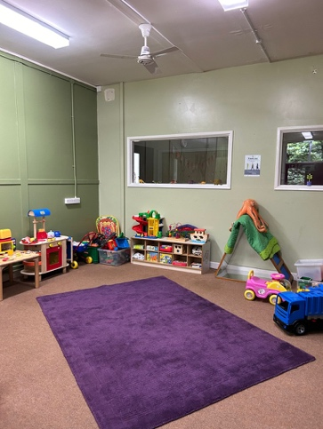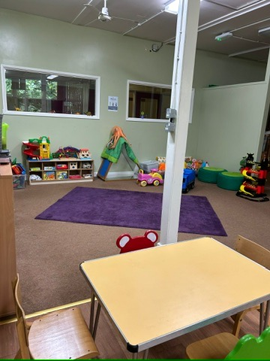

Get in touch

How much is supported contact?

The Referral fee is £20
£80 (Up front) for 2 Preparation sessions and 6 Family Time sessions

How do I arrange supported contact? Directly by you, self-referral or through a Solicitor Call Telephone: 07852 625219 or email Office@parentingapartcentreeast.co.uk

