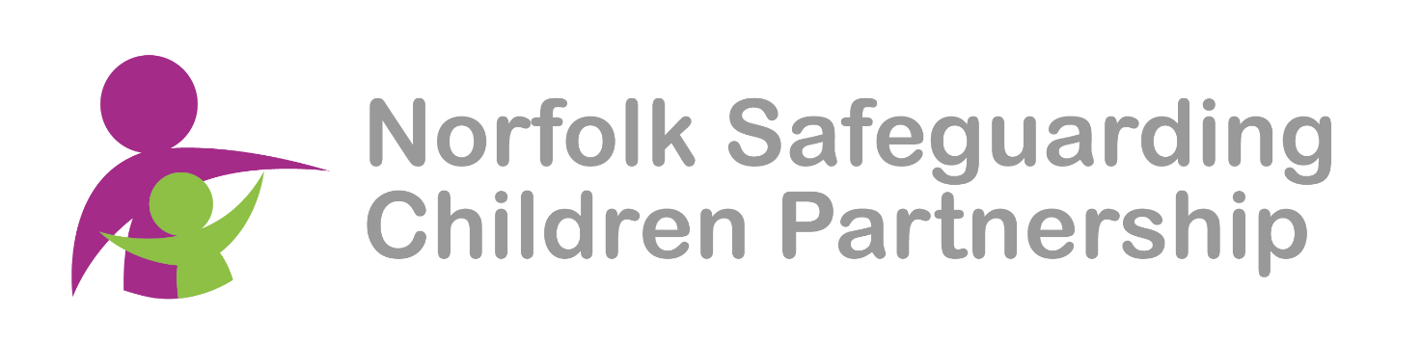
Multi-Agency Report to Child Protection Conference
Guidance Notes
Norfolk Safeguarding Children Partnership (NSCP) has adopted Signs of Safety (SoS) as the basis of work with children across all partner agencies engaged in providing services for Children in Norfolk. Signs of Safety has also been adopted by Norfolk County Council Children’s Services and the Norfolk Children and Young People’s Strategic Partnership Board as the core philosophy for working with children and families across Norfolk.
Central to this approach is the use of specific practice tools and processes where family members and Workers can engage with each other in partnership to address and work together on solutions to reduce the risks to children.

Child Protection Conference Reports
The expectation is that all Workers working within the NSCP procedures will provide a written report to Conference whether they are able to attend the Conference or not.
NSCB Multi Agency Template
A copy of the latest form will always be available on the NSCP website, link below.
Child Protection Conferences and Contextual Safeguarding Conferences - Norfolk Safeguarding Children Partnership (norfolklscb.org) (Multi-Agency Child Protection Conference Report Form)
Translation
Where family members first language is not English, please ensure that your reports are translated into the family’s first or preferred written language.

3rd Party Information
3rd party information will now be shared with workers during the pre-conference reading time, prior to the start of the actual meeting. If your agency has information which should be managed as 3rd party, please ensure that you inform the Chairperson or Conference Administrator immediately on arrival at the meeting.
When you are unable to attend a Child Protection Conference
If you are unable to attend a Conference, it is expected that a colleague would attend on your behalf. That colleague should be fully briefed on your involvement and bring your report.
It is understood that Schools/Colleges and Educational providers may not always be able to attend a Child Protection Conference during School Holidays. However, a report with a clear analysis and proposed recommendation should always be provided.
Where to send your Conference Report
A copy of the report should be forwarded to the Independent Reviewing Service Business Support email address cs.bsupport.bowthorpe@norfolk.gov.uk marked FAO of the named Child Protection Chair, at least 48 hours in advance (for ICPC) and 3 days in advance (for RCPC).
Sharing your Report with family

The Report Author should share the contents of the report with the Parents / Carers / Family / Child / Young Person, in the advanced timescale noted above of the Conference.

*It is accepted that restricted information cannot always be shared prior to a Conference.
*It may be necessary to provide separate reports where some family members should not have access to some of the report i.e. for Split Conferences/contains person specific data.
* There should be no information added to the report that you have not shared with family in advance.
--------------------------------
Structure of your Report

The Multi-Agency Report to Child Protection Conference is now structured to support Workers from all agencies to share information using the following -

Overview of your agency’s involvement with child/family
- Type of service offered by your agency (brief overview)
- First time the family became known to your service.
- Why are you involved with the family currently?

What are we worried about now?
- Past Harm
Information about past harm/danger that has occurred for the child, their siblings or their parents/carers which could increase the risk of harm currently.
- Current Harm and Impact
The Risks that are harmful or pose a risk of significant harm to the child currently.
- Complicating factors
Things that make life more difficult or complicated ie. adult behaviours, special needs, diversity, language differences etc…

What is the impact on the child if the risks are not reduced?
- What do you believe will be the likely outcome for the child(ren) if their current situation continues?

What is working well for the child that reduces the risks and increases the child’s safety and resilience?
- Identify family strengths and safe behaviours (Include strengths within the wider family network which increases safety).

The Report further gives opportunity for agencies to indicate how their services may be able to support parents to address the risks identified.
Within your own agency’s provision……
- Identify the risks, briefly describe what you would expect to see when a child is safe and not at risk of harm and the identified action that your agency can offer.

Workers must ensure that they seek the views of children, young people and family adults about their situation and on the report.

Child/young person’s views on their situation and on the report.
*Please ensure you have the child’s permission to share their views with parent/carers and with conference members.
Parents’/carers’ views on the situation and on the report
- Views on the support you have provided and whether they think this has helped their child.
- Parent’s/carer’s view of the information contained within this report.

The final section of the report provides space for your proposed recommendation.
- Please consider for each child/young person on a scale of 0 to 10 if the child is safe and their needs are being met, or the child is at risk of significant ongoing harm and/or their needs are not met.
- Please consider for each child/young person whether the threshold for a Child Protection Plan is met and or their needs can be met via different planning.
- Please consider for each child/young person your reasons for your decision making.
Multi-Agency Report Guidance Note V3 01/10/2022

