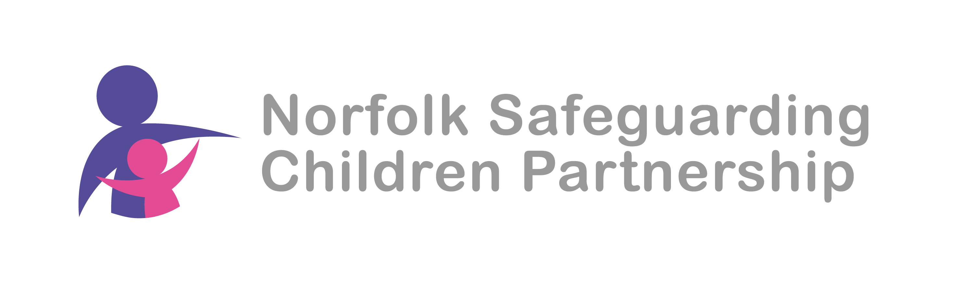

Local Safeguarding Children Group (LSCG) – North and Broadland

Date: 9th July 2024
Venue: MS teams

Present:
Name | Title | Organisation
Philip Beck (PB) | Head of Partnerships, Schools and Communities and co-chair of the LSCG | NCC
Mark Osborn (MO) | Safeguarding Intelligence & Performance Co-ordinator (SIPCo) | NSCP
Zee Bacon (ZB) | Lead Worker | Matthew Project
Steph Edrich (SE) | Head of Locality | Norfolk Healthy Child Service
Lindsey Potter (LP) | Programme Co-ordinator | ECFS
Mel Perry (MP) | Community & Partnership Team manager | NCC
Louise Cowell (LC) | Probation Practitioner | Probation
Simon Godfrey (SG) | DSL | North Walsham Junior School
Mary Thornton (MT) | Psychological Therapist | NSFT
Sally Bailey (SB) | Safeguarding Lead | Horizons Trust
Kirsty Pitcher (KP) | Acting CEO and co-chair of the LSCG | Benjamin Foundation
Ross Wacey (RW) | Programme Coordinator | ECFS

Agenda
- Welcome and introductions
- LSCG members presentation
- NHCP presentation of new service priorities
- NSCP priorities family and community networking
- Outline of family help arrangements
- Next meeting

No. | Item
1 | Welcome and introductions.  KP welcomed the attendees to the meeting and asked them to introduce themselves.
2 | Presentation from LC re Probation  MT question around when DA is not the index offence and how services could link with Probation – discussions will be focused through MASH but there is scope to consider JAGS as an option.  PB How does Probation link with services other than social workers such as in the Family hub approach? LC explained that this is an area that Probation is looking to improve upon including regular attendance at these LSCG meetings  AP MO to let LC about Father inclusive practice training opportunities  MP/RW/LP will link with LC regarding Family hub links and probation join up.
3 | Presentation from SE re service development of the Healthy Child Programme  There was discussion around the value of colleagues making an account on JON  and the value of the FYI website for young people. This is a link to presentation from Fay Spencer re navigating FYI;  https://norfolklscp.org.uk/people-working-with-children/local-safeguarding-children-groups-lscgs
4 | FCN  There was discussion around FCN as a priority and how people are using FN tools?  SB have had training and are looking at how they use this as early intervention and include this in their approach. It is in its infancy but there is a commitment to use it. FCN information and resources are available on JON for families to use which fits into the mindset of families feeling empowered.  Links to FCN tools: https://norfolklscp.org.uk/people-working-with-children/nscp-priorities  Need to myth bust around what FCN is and how it is already happening already within organisations.  Community networks can be different to family networking and can include supporting children and young people with wider community engagement including the places and spaces they spend time in. Community conferences can be used to develop common understanding with communities and provide more robust support networks around young people.
Family help arrangements
J McAllister review has been a driver for making this change.
Operating a family help approach/service being developed in Norfolk. Families can relate to this as a concept. Amalgated Family Support teams with SW teams amongst other benefits should move families away from experiencing change in service and reduce the step up/step down experience. Fundamentally it is based on strong relationships and all children will be part of this including those getting support through Family Support Plans and Child in Need and Child Protection interventions. The alignment and integration has started but not officially launched with partners (this may be in September). CWD to be aligned to this model.

5 | Next meeting  Date: 11th September 10.30  .  Presentations  HB  DT and RW will be preparing presentations so these may be possible

