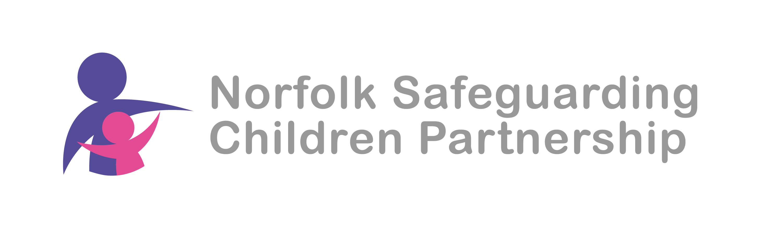
Norfolk Safeguarding Children Partnership (NSCP)
West Local Safeguarding Children Group
21st May 2024
11am
MS teams

Agenda

  - Welcome and introductions
  - Serious Youth Violence Katie Burrell
  - Presentations from LSCG members
  - Multiagency Chronologies
  - A.O.B.
  - Next meeting

Attendees
Name | Job title/Organisation
Andy Nederpal | Community Safety Manager/ Kings Lynn and W Norfolk BC
Charlotte Marriott | Policy Officer/ Kings Lynn and W Norfolk BC
Dave Peat | Norfolk Constabulary
Elanor Goldup | Local First Inclusion Adviser/NCC
Jeanette Nowrung | ECFS
Jill Graver | Headteacher/Greenpark Academy & Blenheim Park Academy
Katharine Robinson | FGC & Family Networking Advisor/NCC
Katie Burrell | Safeguarding Assurance Officer /NCC
Luke Martin | Lead Worker – West & Breckland/The Matthew Project
Mark Osborn | SIPCo/NSCP
Rachel Bazeley-Smith | DSL - Smithdon High

Apologies:
Kerry Biggadike Safeguarding Lead West/HCP
Vicki Horton Head of Partnerships, Schools & Communities/NCC

- MO welcomed all to members to the meeting and colleagues introduced themselves.

- Serious Youth Violence Katie Burrell
Katie shared the summary of key learning from multi-agency audit please see attached presentation

This was followed by discussion
RBS highlighted that it appears to be parents rather than young people who are instigating aggression and feudal behaviour in the West. Students have found it difficult to relate to each other post Covid which causes lack of understanding and potentially leads to violence. There is a good relationship with local police who visit the school regularly
JG We can have problems in the community that then spill into the school. We are also seeing examples of anti-social behaviour in much younger children including year one and year two children. Some of it is intergenerational.
MO raised the lack of cases being put forward to the Accumulated Neglect Operational Oversight Forum (ANOOF) and JG and RBS said that they could identify cases.
Action Point MO to contact KW re these potential cases

- Presentations from LSCG members

JG talked about the work that she does at Greenpark Academy & Blenheim Park Academy which highlighted some of the challenges and how they are addressing them as well as the value of good relationships and partnership working.

KR alerted colleagues to a new resource to provide community conferencing and that colleagues could email communityconferencing@norfolk.gov.uk to access this.

- Multiagency Chronologies

MO talked about the new guidance for using Multi-agency Chronologies which is in the toolkit for Continuum of Needs Guidance https://norfolklscp.org.uk/people-working-with-children/norfolk-continuum-of-needs-guidance

The consensus in the room was about how valuable these chronologies are despite the time needed to complete them.

- A.O.B.
MO mentioned that is Norfolk Practice week and there are many learning opportunities available https://norfolklscp.org.uk/news/norfolk-practice-week-20-24th-may-2024

Fay Spencer is running a briefing for colleagues to learn more about the FYI website and colleagues can book a space on this at https://www.eventbrite.com/e/lscg-briefing-navigating-fyi-website-tickets-897199045497

- Next meeting
Council Chamber at the Town Hall Saturday Market Pl, King's Lynn PE30 5DQ from 10:30 – 12:30 on Monday 15th July 2024

Presentation

Andy Nederpel

