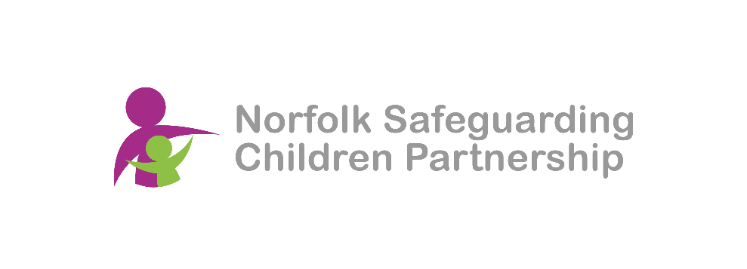

**Norfolk Safeguarding Children Partnership (NSCP)**

**West Local Safeguarding Children Group**

**Date: 11th January 2024**

**Time: 10:00 – 12:00**

**Microsoft Teams**

**Minutes**

|  |  |
| --- | --- |
| Name | Role/Department |
| Chloe Murchie | Executive Assistant |
| Claire Farrelly | Advisor – Safeguarding |
| Charlotte Marriott | West Norfolk |
| Elanor Goldup | LFI |
| Emily Gore-Rowe | DSL Churchill Park Academy |
| Jill Graver | Headteacher- Greenpark Academy |
| Jo Robotham | Head of Customer Services at Freebridge Community Housing |
| Luke Martin | Matthew Project |
| Mark Osborn | NSCP Safeguarding Intelligence & Performance Officer |
| Nikki King | Team Manager Community and Partnership |
| Paul Freeman | Business Support Assistant |
| Paul O'Shea | Assistant Principal - College of West Anglia |
| Patsy Perez | Executive Head of Windmill Primaries |
| Rachel Blasey-Smith | DSL - Smithdon High |
| Simon Barnett | Team Manager - In Care Team |

|  |  |
| --- | --- |
|  | Welcome and introductions. |
|  | Presentations from LSCG members  Nikki King- Communities & Partnerships Team Manager    The Community and Partnerships team is part of Children's Services within the realm of prevention and early help, working with families to provide support as early as possible and avoid crises.  The importance of early help and multi-agency collaboration: The team believes that early help is everyone's responsibility and that it is more effective to promote welfare than to react to problems later. The team uses the signs of safety approach and works with other professionals and agencies to identify the strengths, worries, and needs of families.  The referral routes and pathways for families: The team is part of the multi-agency safeguarding hub (MASH) and can receive requests for support online, by phone, or by walk-ins at the Family Hub. The team also provides information, advice, and guidance to families and partner agencies. The team helps families to access self-help, natural networks, and community services, and coordinates early help assessment and plans (EHP) when needed.  The Family Hub approach and outreach activities: The team is part of the Family Hub core workforce, along with the Healthy Child Programme and the Early Childhood and Family Service. The Family Hub approach aims to support parents and carers with children from conception to 19 (or 25 with SEND). The team offers online, face-to-face, and community outreach services, and is developing peer support opportunities.  The team attends the District Council collaboration meeting to share information and provide guidance. They also work with food banks to overcome the issue of families not using them. The team is also involved in the Tech Skills for Life project, which provides families with free electronic devices and data.  <https://communitydirectory.norfolk.gov.uk/Services/21060>  Simon Barnett – Family Help and High Needs Team Manager  Works with children in care in Norfolk, outlined the legal context, the types of children and placements, and the challenges and interventions of the children in care service.  The different sections of the Children Act of 1989 that govern the intervention and accommodation of children who are at risk of harm. SB also mentions the different stages of the process, from early help to court proceedings, and the different types of orders and placements that can be made.  SB describes the various reasons and circumstances that can lead to children being in care, such as unaccompanied asylum seekers, homeless teenagers, abandoned babies, death of a caregiver, or abuse and neglect. As well as discussing the different types of placements that can be arranged for children in care, such as foster care, residential care, secure accommodation, semi-independent living, or kinship care.  Rachel Bazeley-Smith and Jo Robotham to present next time. |
|  | CoNG toolkit -   1. Ages and stages   The Continuum of Needs Guidance has replaced the threshold guide, and sitting under this is a whole new toolkit.  The Ages and Stages document is still in development. It uses the flourish outcomes for different age groups and provides a tool to consider how well these outcomes are being achieved. At the end of last year we had a safeguarding review and looking back at the chronology for the young man (AL) who committed suicide last year and it was noticeable in the review that none of the FLOURISH outcomes within the framework had been achieved for him.  Mark went through the website (<https://norfolklscp.org.uk/people-working-with-children/norfolk-continuum-of-needs-guidance> ), which showed us where all the resources and documents are kept. One thing we are hoping when we come back together for a face-to-face meeting in March is begin to explore how some people are using these toolkits, and how they work.  **Action:** All members to look at the new Ages and Stages tool with colleagues and give some feedback about whether the descriptors are right and can be used to inform local practice. Feedback to be brought back to the March meeting.  Please note that this document is in development and not to be shared beyond consultation.  **Action:** Between now and March meeting, everyone to go and look at the toolkit which is available online (see above link) and it would be great if staff could have some knowledge of the resources which are available so we can see which things are useful and which things people don’t like and don’t think will be a helpful document.  **Action**: Ask for all colleagues to have a look at the new guidance as there is a lot more information in here compared to the old guide. It is essentially a guide to early help and prevention.   1. A Staged Intervention Pathway for Promoting Good School Attendance   KW who works in the attendance space and shared some data and initiatives showing that attendance in Norfolk has improved in the last academic year, especially in the primary and complex needs sectors, and has closed the gap with the national average and other regions.  KW thanks the LSCGs for their multi-agency work in helping to develop a strategic approach to tackle attendance issues and to raise awareness among professionals and families.  The staged intervention guidance pathway document was discussed as a tool for all professionals, schools and families to respond to attendance concerns at the earliest opportunity, based on the DfE guidance and the continuum of needs guidance.  KW mentioned that there is a media campaign to address some of the changes in attitudes and behaviours around school attendance among parents and carers, and that there are assets that can be used by professionals. They also says that there is a new post that will focus on the attendance of children with a social worker. |
|  | Transitional safeguarding - Moved to f2f session in March |
|  | Next meeting |